**Experiment No - 1**

**Aim**: To study and implement Finite Automata and validate strings using it.

**Date:**

**Competency and Practical Skills:** Understanding and implementing Finite Automata, string validation

**Relevant CO:** CO1

**Objectives:**

1. To understand the concept of Finite Automata.

2. To implement Finite Automata using programming language.

3. To validate strings using Finite Automata.

**Software/Equipment:** Computer system, Text editor, Programming language.

**Theory:**

Finite Automata is a mathematical model that consists of a finite set of states and a set of transitions between these states. It is used to recognize patterns or validate strings. In a Finite Automata, there are five components:

1. A set of states

2. An input alphabet

3. A transition function

4. A start state

5. A set of final (or accepting) states

In the implementation of Finite Automata and string validation, we need to create a Finite Automata that recognizes a specific pattern or set of patterns. The Finite Automata consists of states, transitions between the states, and a set of accepting states. The input string is then validated by passing it through the Finite Automata, starting at the initial state, and following the transitions until the string is either accepted or rejected.

String validation using Finite Automata is useful in a variety of applications, including pattern matching, text processing, and lexical analysis in programming languages. It is an efficient method for validating strings and can handle large inputs with minimal memory and time complexity.

**Example:** Suppose a finite automaton which accepts even number of a's where ∑ = {a, b, c}

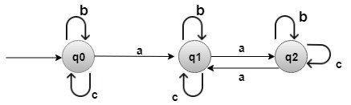

**Solution:**

q0 is the initial state.

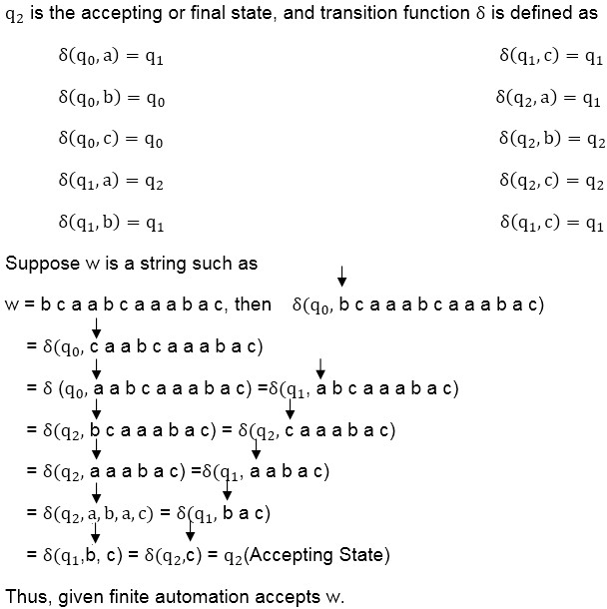

**Suggested Reference:**

1. Introduction to Automata Theory, Languages and Computation by John E. Hopcroft, Rajeev

Motwani, and Jeffrey D. Ullman.

2. [https://www.youtube.com/watch?v=58N2N7zJGrQ&list=PLBlnK6fEyqRgp46KUv4ZY69yX](https://www.youtube.com/watch?v=58N2N7zJGrQ&list=PLBlnK6fEyqRgp46KUv4ZY69yXmpwKOIev)

[mpwKOIev](https://www.youtube.com/watch?v=58N2N7zJGrQ&list=PLBlnK6fEyqRgp46KUv4ZY69yXmpwKOIev)

3. GeeksforGeeks: Finite Automata Introduction - [https://www.geeksforgeeks.org/introduction-](https://www.geeksforgeeks.org/introduction-of-finite-automata/) [of-finite-automata/](https://www.geeksforgeeks.org/introduction-of-finite-automata/)

**Rubric wise marks obtained:**

|  |  |  |  |  |  |  |  |  |  |  |  |
| --- | --- | --- | --- | --- | --- | --- | --- | --- | --- | --- | --- |
| **Rubrics** | **Knowledge**  **(2)** | | **Problem**  **Recognition**  **(2)** | | **Implementat ion (2)** | | **Testing & Debugging (2)** | | **Creativity in logic/code (2)** | | **Total** |
| **Good**  **(2)** | **Avg.**  **(1)** | **Good**  **(2)** | **Avg.**  **(1)** | **Good**  **(2)** | **Avg.**  **(1)** | **Good**  **(2)** | **Avg.**  **(1)** | **Good**  **(2)** | **Avg.**  **(1)** |
| **Marks** |  |  |  |  |  |  |  |  |  |  |  |